PACIFIC MARINE & INDUSTRIAL®
P.O. Box 70520, Richmond, California, United States 94807-0520
510-233-2310 ◊ info@PacificMarine.net ◊ www.PacificMarine.net

Information Needed for

Hydraulic Power Units – HPU Quotations

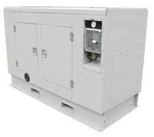 | 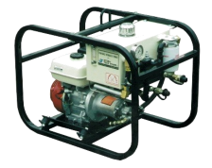 | 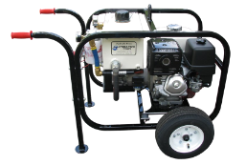 | 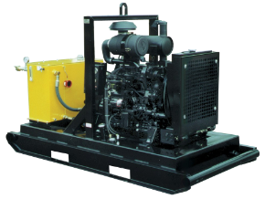 | 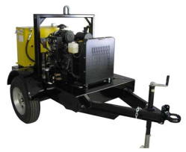

1. What is the hydraulic power unit (HPU) power source?
- Electric
- Engine Powered – Gasoline
- Engine Powered – Diesel

2. If Electric, what is the power supply available?
- 50 or 60 Hz?
- Volts?
- 1 or 3 phase?

3. What is the needed pressure and flow rate of the hydraulic fluid output?
- Pressure?
- Flow rate?
- PM&I to decide based on equipment being purchased?

4. What is the HPU configuration?
- Stationary and fixed in place
- Portable – Hand Carried – No Wheels
- Portable – Hand Carried – Tilts onto Wheels
- Portable – On Skid with Forklift Pockets
- Portable – On Wheels - Trailer Mounted

5. Controls Included?
- Describe

6. Special Requirements?
- Hazardous Location
- Tier 4 Final Engine
- ???

7. Location for Delivery?

